*Florida International University*

*School of Computing and Information Sciences*

Software Engineering Focus

Feature Document

User Story ID <NVOS-6 View Cite>

**Name:** Bryan Bastida

**Team Member(s):** Bryan Bastida

Andrew Castillo

**Project:** Envo Scholar

**Product Owner(s)**: Mark Finlayson

**Mentor(s)**: Masoud Sadjadi

**Instructor**: Masoud Sadjadi

**User Story Name: View Citations**

* Description: As a user, I want to click a button that displays different citation formats for the article results, so that I can get the citation for the article.

Acceptance Criteria

* User entered a search query
* Database successfully returned articles related to the search
* Article links are displayed on the screen
* User pressed Cite button
* Citations popout on a new window

**Use Case**

* **Name**: Cite
* **Actor**: User and Web Page
* **Preconditions**: Article links are displayed on web page as well is link for Cite
* **Description** <Flow of events>:
  + User types a search query and hits the Search button
  + Search query is sent to the database
  + Database returns articles
  + Web page displays article links and link for Cite
  + User hits the Cite link
  + The citations opens on a new window

**Use Case Diagram**

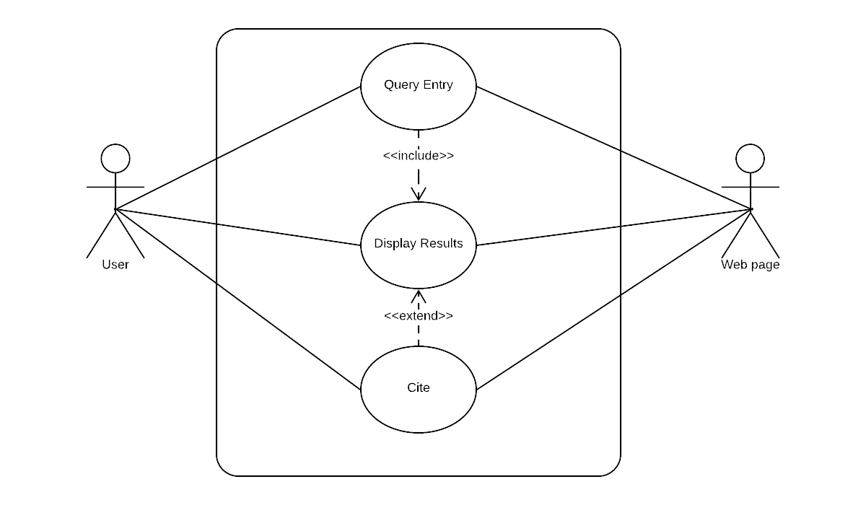**Sequence Diagram**

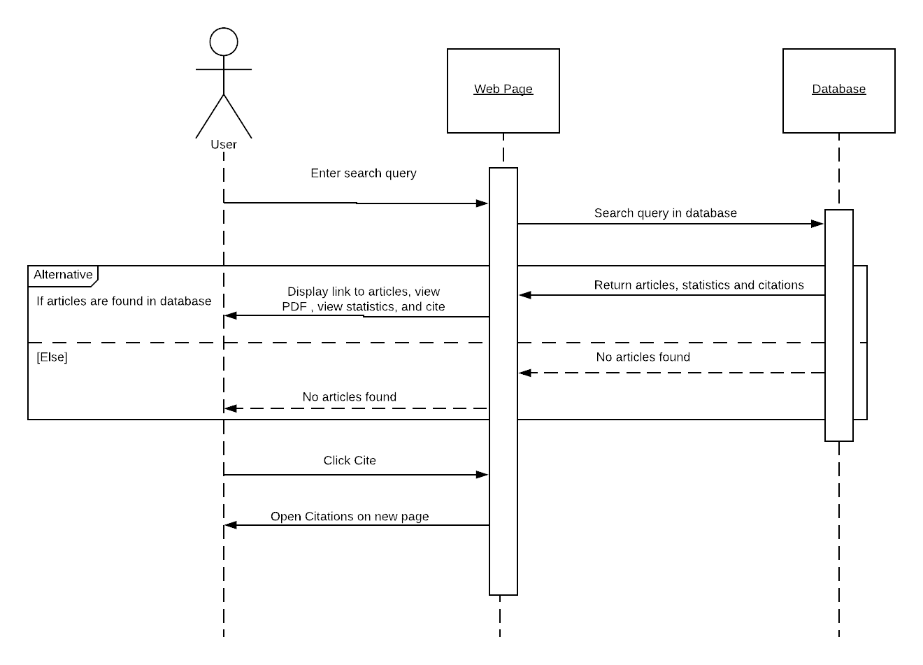

**Class Diagram**

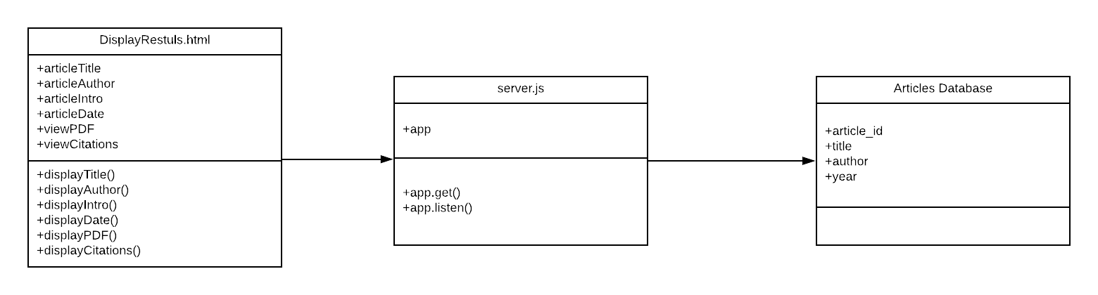

**Visual User Guide**

